**Culminating Project**

**The Ideal Playground**

You and your team will design what you consider the best playground. You will present your playground and highlight why your playground is fun, safe, and promotes fitness.

Your team will also need to show how your playground meets all the requirements listed below.

**Playground Requirements:**

* Playground fits within a rectangular area that is 70 feet wide and 90 feet long
* Includes at least one playground system
* Includes at least one individual feature
* Shows consideration of the survey data of what activities students say are “fun”
* Includes activities that promote fitness
* Meets the groundcover guidelines for safety

Student Survey

What makes a playground fun?

Tell how much you enjoy each playground feature.

|  |  |  |  |  |  |
| --- | --- | --- | --- | --- | --- |
|  | **I do not enjoy this activity** | **This activity is OK** | **I like this activity** | **I really like this activity** | **This is my favorite activity** |
| Swings |  |  |  |  |  |
| Slides |  |  |  |  |  |
| Climbing walls |  |  |  |  |  |
| Rope bridges |  |  |  |  |  |
| Teeter totter |  |  |  |  |  |
| Balance beams |  |  |  |  |  |

What makes a playground fun?

Tell how much you enjoy each playground feature.

|  |  |  |  |  |  |
| --- | --- | --- | --- | --- | --- |
|  | **I do not enjoy this activity** | **This activity is OK** | **I like this activity** | **I really like this activity** | **This is my favorite activity** |
| Swings |  |  |  |  |  |
| Slides |  |  |  |  |  |
| Climbing walls |  |  |  |  |  |
| Rope bridges |  |  |  |  |  |
| Teeter totter |  |  |  |  |  |
| Balance beams |  |  |  |  |  |

Playground Information Form

**Complete this form for each system and feature you include in your ideal playground. Then use the information to complete the table to represent all of the equipment in your playground**

Name: __________________________________

Is this an individual feature or a playground system? __________________________

Name and Model Number of item: ______________________________________

Appropriate age range for this item: ____________________________________

Dimensions for the “Use Zone” _________________________________________

Area of “Use Zone” _________________________________

Fall Height: __________________________

Approximate price: ____________________________

Why did your team select this item?

Playground Information Table

**Complete this form to represent all of the systems and features included in your ideal playground**

Name: _________________________________________

|  |  |  |  |  |  |  |  |
| --- | --- | --- | --- | --- | --- | --- | --- |
| **Name and Model Number** | **System or Feature** | **Age Range** | **Dimensions for Use Zone**  **(in feet)** | **Area of Use Zone (square feet)** | **Fall Height**  **(inches)** | **Price** | **Why did your team select this item** |
|  |  |  |  |  |  |  |  |
|  |  |  |  |  |  |  |  |
|  |  |  |  |  |  |  |  |
|  |  |  |  |  |  |  |  |
|  |  |  |  |  |  |  |  |
|  |  |  |  |  |  |  |  |
|  |  |  |  |  |  |  |  |

Grid paper for playground sketch

|  |  |  |  |  |  |  |  |  |  |  |  |  |  |  |  |  |  |  |  |  |  |  |  |  |  |  |  |  |  |  |  |  |  |  |
| --- | --- | --- | --- | --- | --- | --- | --- | --- | --- | --- | --- | --- | --- | --- | --- | --- | --- | --- | --- | --- | --- | --- | --- | --- | --- | --- | --- | --- | --- | --- | --- | --- | --- | --- |
|  |  |  |  |  |  |  |  |  |  |  |  |  |  |  |  |  |  |  |  |  |  |  |  |  |  |  |  |  |  |  |  |  |  |  |
|  |  |  |  |  |  |  |  |  |  |  |  |  |  |  |  |  |  |  |  |  |  |  |  |  |  |  |  |  |  |  |  |  |  |  |
|  |  |  |  |  |  |  |  |  |  |  |  |  |  |  |  |  |  |  |  |  |  |  |  |  |  |  |  |  |  |  |  |  |  |  |
|  |  |  |  |  |  |  |  |  |  |  |  |  |  |  |  |  |  |  |  |  |  |  |  |  |  |  |  |  |  |  |  |  |  |  |
|  |  |  |  |  |  |  |  |  |  |  |  |  |  |  |  |  |  |  |  |  |  |  |  |  |  |  |  |  |  |  |  |  |  |  |
|  |  |  |  |  |  |  |  |  |  |  |  |  |  |  |  |  |  |  |  |  |  |  |  |  |  |  |  |  |  |  |  |  |  |  |
|  |  |  |  |  |  |  |  |  |  |  |  |  |  |  |  |  |  |  |  |  |  |  |  |  |  |  |  |  |  |  |  |  |  |  |
|  |  |  |  |  |  |  |  |  |  |  |  |  |  |  |  |  |  |  |  |  |  |  |  |  |  |  |  |  |  |  |  |  |  |  |
|  |  |  |  |  |  |  |  |  |  |  |  |  |  |  |  |  |  |  |  |  |  |  |  |  |  |  |  |  |  |  |  |  |  |  |
|  |  |  |  |  |  |  |  |  |  |  |  |  |  |  |  |  |  |  |  |  |  |  |  |  |  |  |  |  |  |  |  |  |  |  |
|  |  |  |  |  |  |  |  |  |  |  |  |  |  |  |  |  |  |  |  |  |  |  |  |  |  |  |  |  |  |  |  |  |  |  |
|  |  |  |  |  |  |  |  |  |  |  |  |  |  |  |  |  |  |  |  |  |  |  |  |  |  |  |  |  |  |  |  |  |  |  |
|  |  |  |  |  |  |  |  |  |  |  |  |  |  |  |  |  |  |  |  |  |  |  |  |  |  |  |  |  |  |  |  |  |  |  |
|  |  |  |  |  |  |  |  |  |  |  |  |  |  |  |  |  |  |  |  |  |  |  |  |  |  |  |  |  |  |  |  |  |  |  |
|  |  |  |  |  |  |  |  |  |  |  |  |  |  |  |  |  |  |  |  |  |  |  |  |  |  |  |  |  |  |  |  |  |  |  |
|  |  |  |  |  |  |  |  |  |  |  |  |  |  |  |  |  |  |  |  |  |  |  |  |  |  |  |  |  |  |  |  |  |  |  |
|  |  |  |  |  |  |  |  |  |  |  |  |  |  |  |  |  |  |  |  |  |  |  |  |  |  |  |  |  |  |  |  |  |  |  |
|  |  |  |  |  |  |  |  |  |  |  |  |  |  |  |  |  |  |  |  |  |  |  |  |  |  |  |  |  |  |  |  |  |  |  |
|  |  |  |  |  |  |  |  |  |  |  |  |  |  |  |  |  |  |  |  |  |  |  |  |  |  |  |  |  |  |  |  |  |  |  |
|  |  |  |  |  |  |  |  |  |  |  |  |  |  |  |  |  |  |  |  |  |  |  |  |  |  |  |  |  |  |  |  |  |  |  |
|  |  |  |  |  |  |  |  |  |  |  |  |  |  |  |  |  |  |  |  |  |  |  |  |  |  |  |  |  |  |  |  |  |  |  |
|  |  |  |  |  |  |  |  |  |  |  |  |  |  |  |  |  |  |  |  |  |  |  |  |  |  |  |  |  |  |  |  |  |  |  |
|  |  |  |  |  |  |  |  |  |  |  |  |  |  |  |  |  |  |  |  |  |  |  |  |  |  |  |  |  |  |  |  |  |  |  |
|  |  |  |  |  |  |  |  |  |  |  |  |  |  |  |  |  |  |  |  |  |  |  |  |  |  |  |  |  |  |  |  |  |  |  |
|  |  |  |  |  |  |  |  |  |  |  |  |  |  |  |  |  |  |  |  |  |  |  |  |  |  |  |  |  |  |  |  |  |  |  |
|  |  |  |  |  |  |  |  |  |  |  |  |  |  |  |  |  |  |  |  |  |  |  |  |  |  |  |  |  |  |  |  |  |  |  |
|  |  |  |  |  |  |  |  |  |  |  |  |  |  |  |  |  |  |  |  |  |  |  |  |  |  |  |  |  |  |  |  |  |  |  |
|  |  |  |  |  |  |  |  |  |  |  |  |  |  |  |  |  |  |  |  |  |  |  |  |  |  |  |  |  |  |  |  |  |  |  |
|  |  |  |  |  |  |  |  |  |  |  |  |  |  |  |  |  |  |  |  |  |  |  |  |  |  |  |  |  |  |  |  |  |  |  |
|  |  |  |  |  |  |  |  |  |  |  |  |  |  |  |  |  |  |  |  |  |  |  |  |  |  |  |  |  |  |  |  |  |  |  |
|  |  |  |  |  |  |  |  |  |  |  |  |  |  |  |  |  |  |  |  |  |  |  |  |  |  |  |  |  |  |  |  |  |  |  |
|  |  |  |  |  |  |  |  |  |  |  |  |  |  |  |  |  |  |  |  |  |  |  |  |  |  |  |  |  |  |  |  |  |  |  |
|  |  |  |  |  |  |  |  |  |  |  |  |  |  |  |  |  |  |  |  |  |  |  |  |  |  |  |  |  |  |  |  |  |  |  |
|  |  |  |  |  |  |  |  |  |  |  |  |  |  |  |  |  |  |  |  |  |  |  |  |  |  |  |  |  |  |  |  |  |  |  |
|  |  |  |  |  |  |  |  |  |  |  |  |  |  |  |  |  |  |  |  |  |  |  |  |  |  |  |  |  |  |  |  |  |  |  |
|  |  |  |  |  |  |  |  |  |  |  |  |  |  |  |  |  |  |  |  |  |  |  |  |  |  |  |  |  |  |  |  |  |  |  |
|  |  |  |  |  |  |  |  |  |  |  |  |  |  |  |  |  |  |  |  |  |  |  |  |  |  |  |  |  |  |  |  |  |  |  |
|  |  |  |  |  |  |  |  |  |  |  |  |  |  |  |  |  |  |  |  |  |  |  |  |  |  |  |  |  |  |  |  |  |  |  |
|  |  |  |  |  |  |  |  |  |  |  |  |  |  |  |  |  |  |  |  |  |  |  |  |  |  |  |  |  |  |  |  |  |  |  |

**Area of “Use Zone”**

**Formative Assessment A**

Name: _____________________________________ Date: ________________

Mia and Tony selected the playground system pictured below.

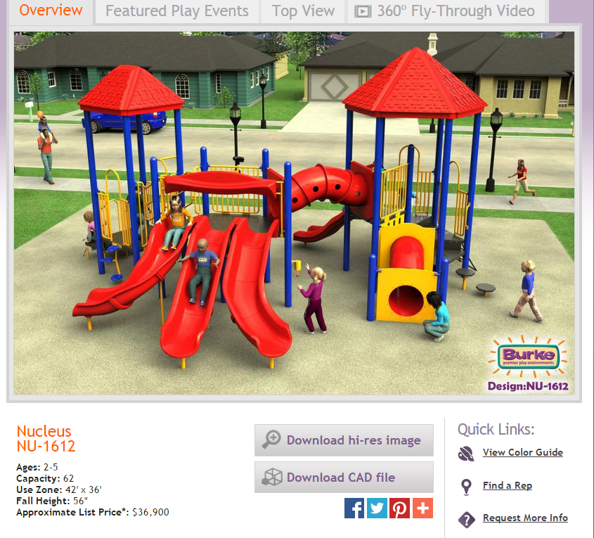

Tony and Mia are discussing the area of the “Use Zone”.

* Tony says the area of the “Use Zone” is 156 square feet.
* Mia says the area of the “Use Zone” is 1,512 square feet.

Which student is correct?

Support your answer using words and numbers.

**Ground Material Needed**

**Formative Assessment B**

Name: _____________________________________ Date: ________________

Mia and Tony selected the playground system pictured below.



Tony and Mia agree to use pea gravel for groundcover.

Review the guidelines for loose fill groundcover.

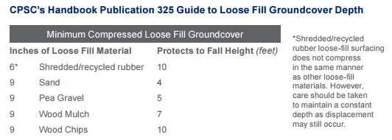

Remember to include $\frac{1}{4}$ **times more** material than the recommended depth.

Round the depth up to the nearest whole inch.

How many cubic feet of pea gravel is needed?

Use words and numbers to support your answer.

Presentation Preparation

Name: ________________________________ Team: ___________________ Date: __________

When you present your playground, everyone in your group should know how and why you designed your playground the way you did. Use the form below to help plan for your presentation.

|  |  |
| --- | --- |
| **Part of Presentation** | **Name of team member** |
| Who will introduce your team and the purpose of the presentation? |  |
| Who will introduce the sketch of your ideal playground? |  |
| Materials Specialist:   * Explain the different types of features and systems included in your playground. * Which items are individual features and which are systems? * Explain where the Use Zone is for each item. |  |
| Profile Specialist:   * Explain why you chose specific features such as slides, swings, benches, etc. * Explain a few benefits for selecting the features. * What is the age range of people using each feature in your playground? |  |
| Fitness Specialist:   * Explain how each item in your playground promotes fitness. * Explain how people with physical handicaps (such as wheelchairs) can use your playground. |  |
| Safety Specialist:   * Explain how you calculated the depth of the groundcover needed to protect from injuries from falls. * Explain what other features makes your playground safe. |  |
| Who will explain and show the total budget? |  |
| Who will summarize the project? |  |

**Culminating Individual Performance Task**

Name: _______________________________________ Date: _________________

Your school is getting a new playground system.

The school has identified two possible playground systems.

The information for each system is listed beside each picture below.

**System 1**

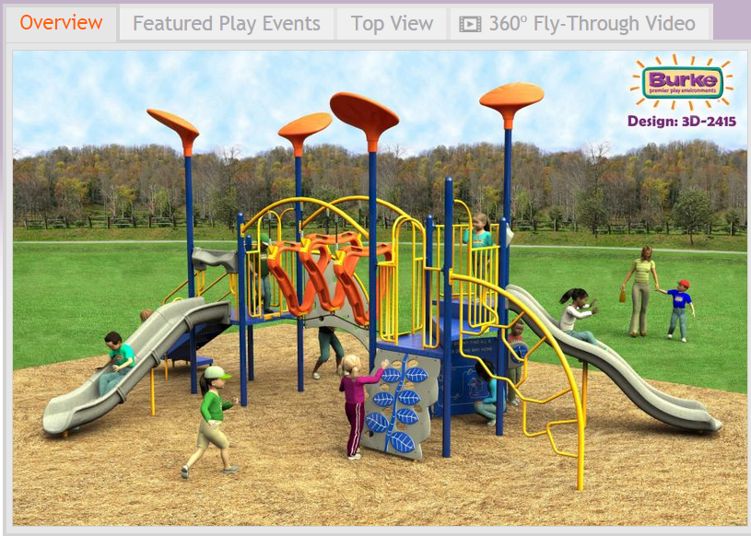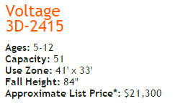

**System 2**

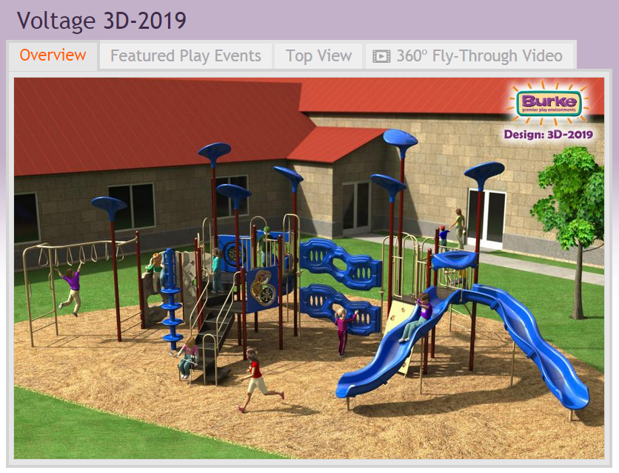 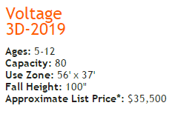

1. Explain why each playground is considered a system rather than an individual feature.
2. Use the information for System 1 and 2 to help you answer this question.

What is the difference, in dollars, between the list prices of the playgrounds?

1. Use the information for System 1 and 2 to help you answer this question.

Complete the table to show the fall height, in **feet**, for each playground.

|  |  |
| --- | --- |
| **Playground** | Fall Height (in **feet**) |
| System 1 |  |
| System 2 |  |

1. Which playground system would need more cubic feet of groundcover?

Use words and numbers to support your answer.

1. Write a letter to your teacher explaining which playground system the school should purchase.

Include the following in your letter:

* What aspects of the system are fun and promote fitness.
* Which type of groundcover you think the school should use and the depth that is needed.
* Use words and numbers to support your answer.

Use the guideline below to make your recommendation for the type of groundcover.

